**C:\Users\Rajagopaalan\Desktop\**Xmlvalidation\Xmlvalidation\person.xml ----xml file

**C:\Users\Rajagopaalan\Desktop\**Xmlvalidation\Xmlvalidation\personssh.xsd ---xsd file

**C:\Users\Rajagopaalan\Desktop\**Xmlvalidation\Xmlvalidation\person.xsml --- xsl file

The bolded path needed to be replaced after the Project folder is moved to the respective systems.

Persons.xml displayed using XSLT transformation

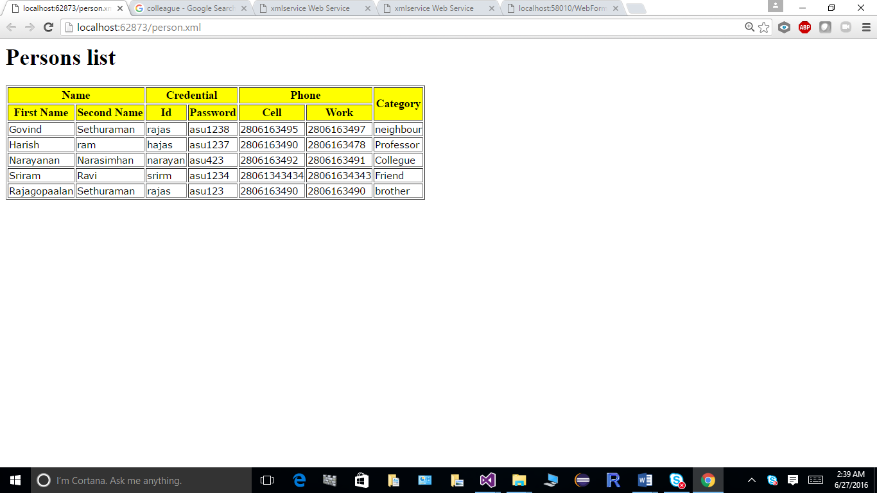

1.Xpathsearch :

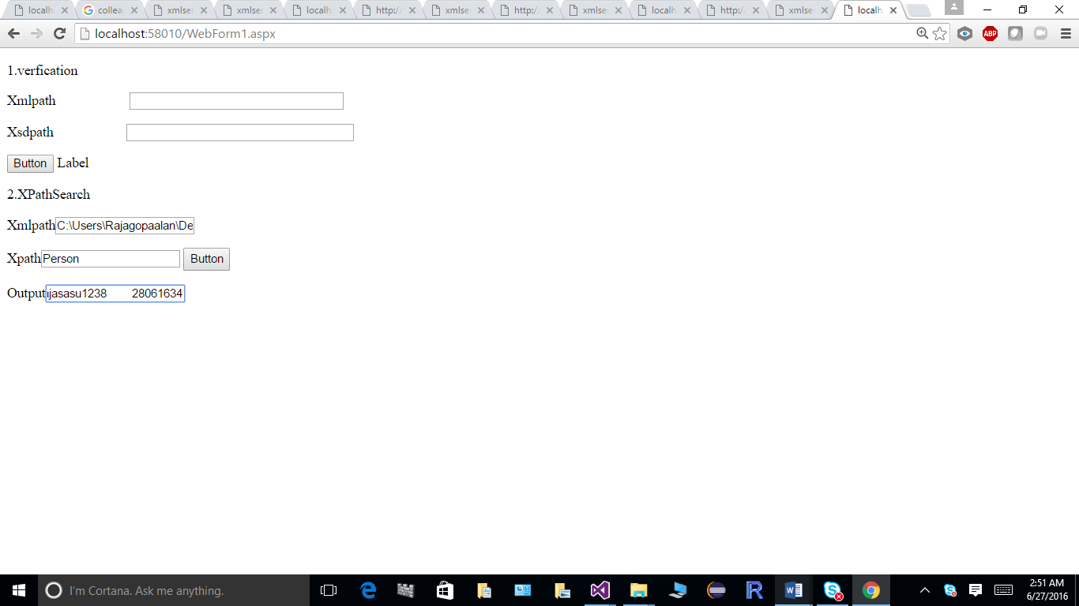

2 Xml and xsd validation:

Testcase : No error

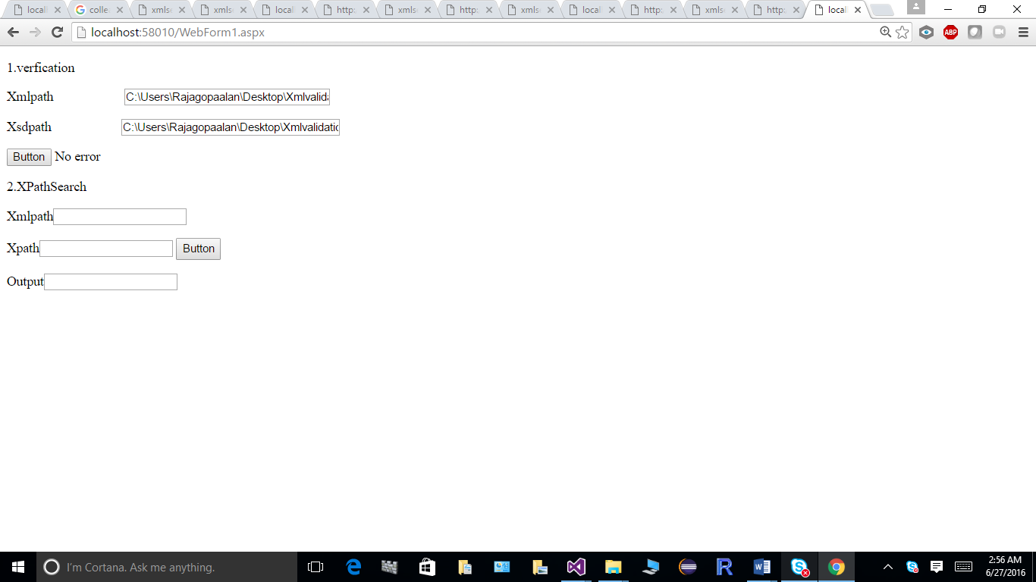

Testcase: with error

